JavaScript demo application
(initial release)

Table of Contents

1. Purpose 3
2. functional requirements 3
3. the project overview 3
3.1. Forces addition by an angle 3
3.2. Archimedes principle 3

Purpose
This software application is the pure JavaScript HTML5 solution. Program purpose is to demonstate JS possibilities. The solution contains different models from the world of physics of mechanics chapter

functional requirements
The application has been created in the MS Viual Studio Code environment and can be launched in modern browsers

the project overview
The projects has the following models:

Forces addition by an angle
This model can show how to calculate resultant of two forces directed at an angle to each other as it shown at the picture below
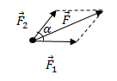
The equation for calculation is: 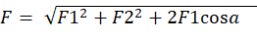
User is allowed to suspend three cargos to the dynamometers , to change their weight , angle and maximum value indicator (Newtons) for the dynamometers
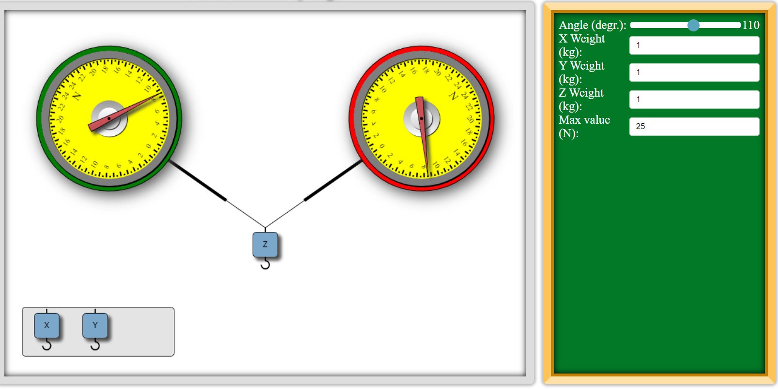

Archimedes principle
This model has not been completed yet
